Wollaston Child Care November 2017

Dressing for fall Weather

With the change in weather, we never know what we are getting in New England!! But the crisp fall air had arrived! Please remember to dress your child appropriately for outside. All class rooms will continue to go out weather permitting, If you have any questions about the guidelines please stop by the front desk and ask. Also remember to label your child’s clothing and belongings in case they get misplaced.

WCCC Closings
• • •
The center will be closed Friday, November 10th in observance of Veterans Day! Honor our military on Veteran’s Day!
We will be closed Thursday November 23rd & Friday November 24th to celebrate Thanksgiving! We hope you and your family have a fabulous long holiday weekend! Enjoy all the scrumptious food and time with friends and family!

Thank you to the families that ordered books! Getting books into your little ones hands helps them become successful lifelong readers! Those books should arrive by Nov. 13th. Continue to look for the monthly flyers with new, exciting, affordable books each month!
Candle Fundraiser
We need your help! We are trying to raise money to support special activities through the long winter months! We will be starting a candle fundraisers, all candles cost $10. Super simple even if every child sells 2 candles it would be helpful. Though the more the merrier! They make a great gift.
Holiday Season
With the Holidays approaching we want to improve our holiday practices with our new & old families. We would love your input, attached to the newsletter is a short survey. If you could take a few minutes
We invite you to join us on Tuesday, November 21st to have a Thanksgiving Feast!! Each classroom will help to create a dish for our bountiful, fantastic feast!! This will be a fun event for families to enjoy! We hope to see many of you there!
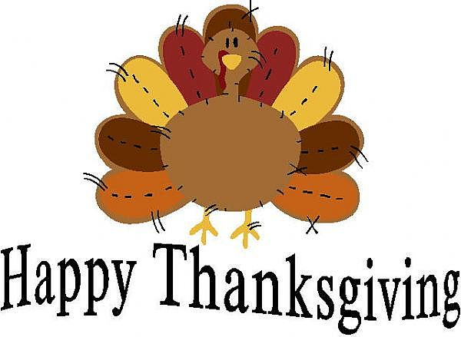

to fill it out to give us some suggestions or input to help us make your holiday traditions reflect in the classrooms! Thank you in advance. Also if you are planning to take vacation and days off please let us know in advance.
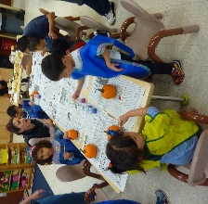
Open House Thanks to those who were able to attend open house! It was nice to see your faces. Those who could not we enjoy seeing you at pick up. We will always make time to say hello and address any of you needs.

Ashton W. 11/12
Brain Z. 11/18
Connie L. 11/19
Nicole W. 11/20
Emily L. 11/21
Evelyn L. 11/22

