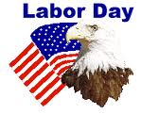
We will be closed on Monday, September 4th in observance of Labor Day. We hope you all have a safe and enjoyable holiday.

Christian V. 9/07
Samantha W. 9/08
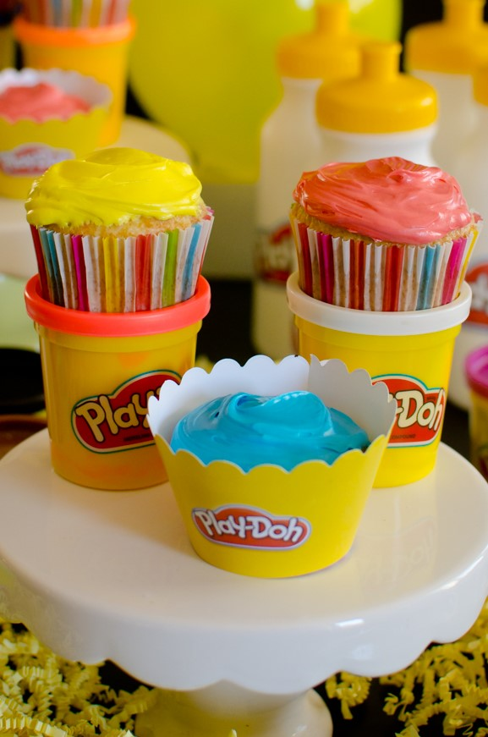
Kayden C. 9/12
Niamh M. 9/18
Shaurya G. 9/23
Evan L. 9/26
Aadhya 9/29
Play-Doh. 9/16
On September 16, the PLAY-DOH brand will celebrate its Birthday!!! This is World Play–Doh Day, a day dedicated to the childhood staple that continues to inspire millions of people of all ages across the globe to open a can of imagination! If you don’t have a can follow these simple instructions to make your own!
2 cups plain flour (all purpose)
2 tablespoons vegetable oil
1/2 cup salt
2 tablespoons cream of tartar
Up to 1.5 cups boiling water (adding in increments until it feels just right)
Food coloring (optional)
Mix the flour, salt, cream of tartar and oil in a large mixing bowl
Add food coloring to the boiling water then into the dry ingredients
Stir continuously until it becomes a sticky, combined dough
Allow it to cool down then take it out of the bowl and knead it vigorously for a couple of minutes until all of the stickiness has gone. * This is the most important part of the process, so keep at it until it’s the perfect consistency!*
(If it remains a little sticky then add a touch more flour until just right)

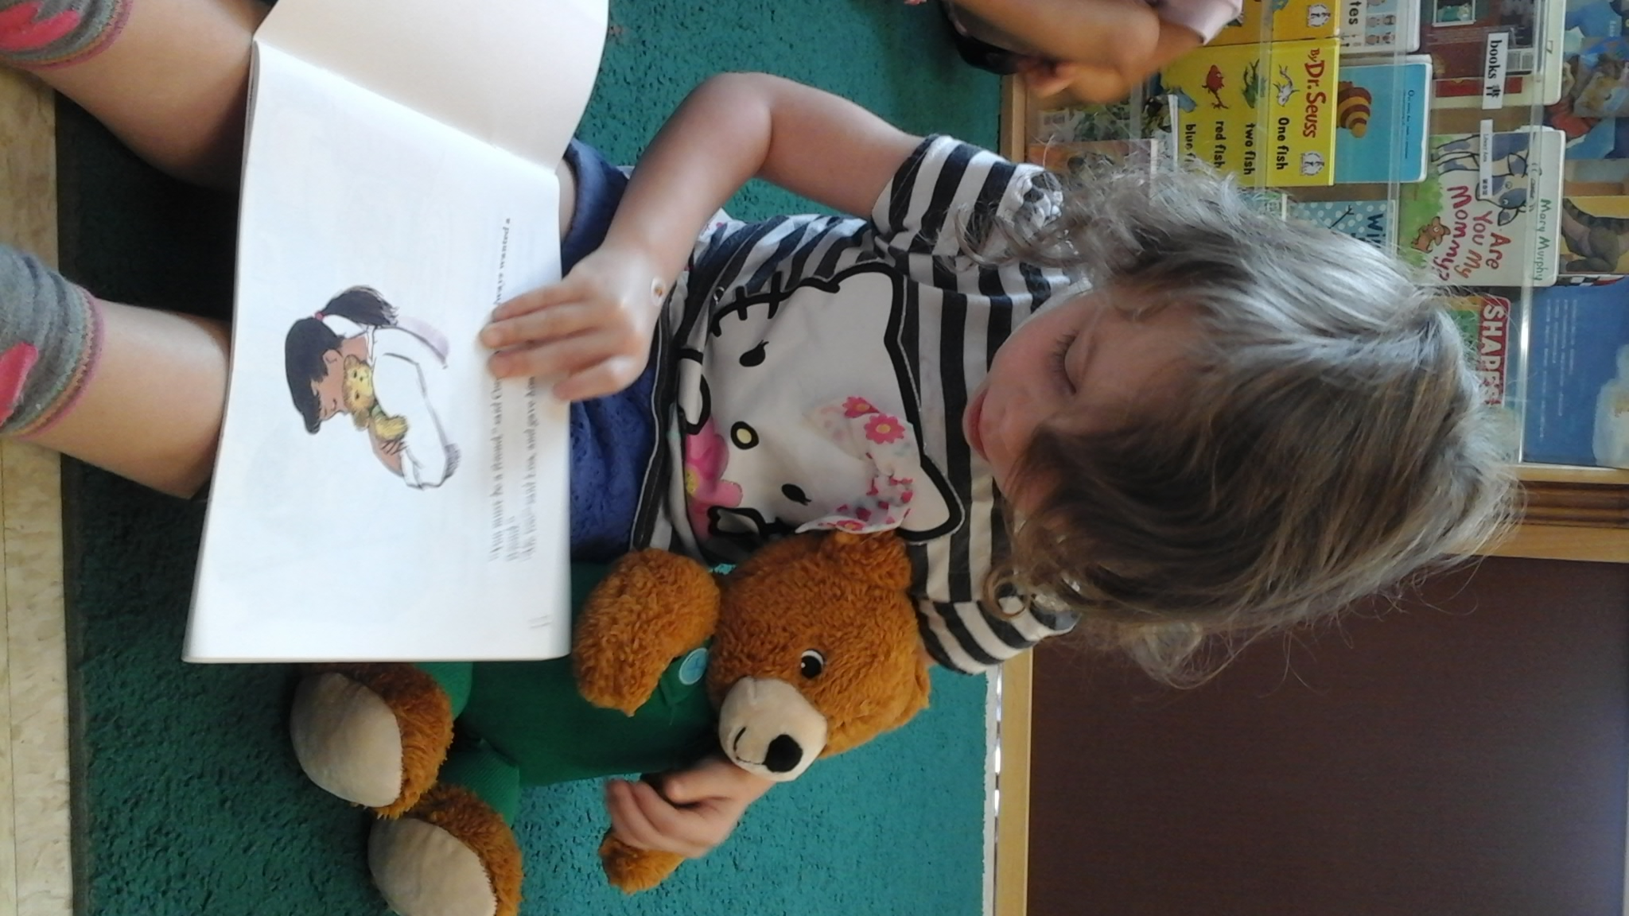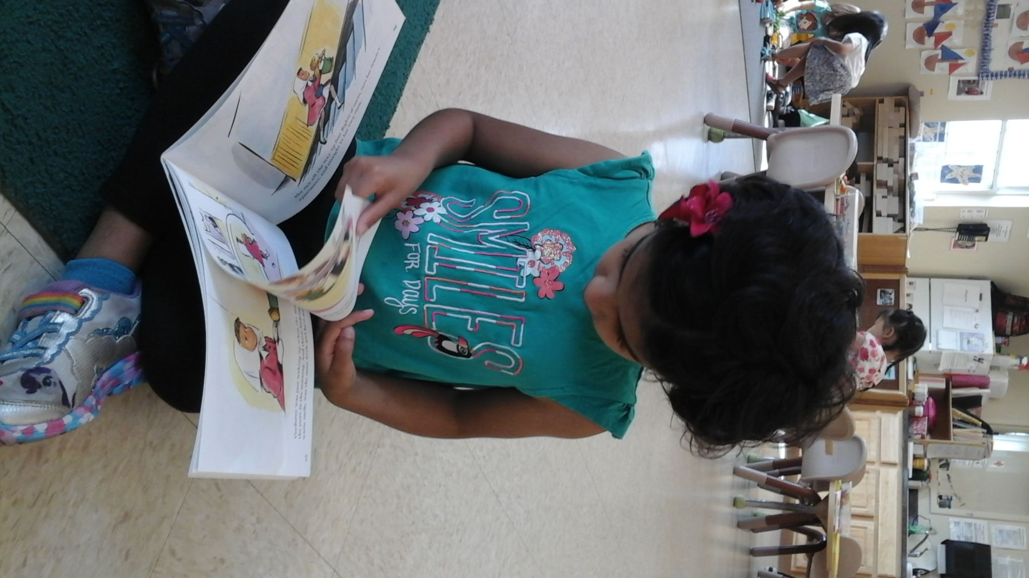
Wednesday, September 6th is National read a book day. Take some time to bond and read a story with your child, they are never too young to start! Instilling a love of reading in your child early will help to ensure a brighter academic future for them. Studies have shown that children who were introduced to books at an earlier age did better throughout their school years and more of them went on to college. Being familiar with books helps children to gain a better understanding of the world around them. Their brains are constantly forming connections, the pictures in the books will be something that they are able to relate to. Reading books aloud to your child also helps prepare them to begin speaking. Introducing books early has multiple benefits and is a key to your child's academic future. Below are some of the many advantages of developing early literacy skills in your child.
- Neurological
Reading helps to develop a young child's brain
- Educational
Reading opens the door to your child's early academic success, imparts a love of learning and leads to higher grades in every subject
- Psychological
….grows in self-confidence and independence….early reading ignites the child's creativity and imagination.
- Social
Early readers have the opportunity to relate to their peers on a more confident, more competent level as they are already being recognized for their superior accomplishments. Such experiences increase the child's social status among peers as well as his or her self-image and self-confidence.
- Linguistic
The sooner children learn how to read, the more books, knowledge, and ideas they will be exposed to. The result? Improved linguistic skills in the form of a richer vocabulary, correct grammar, improved writing, better spelling and more articulate oral communication.
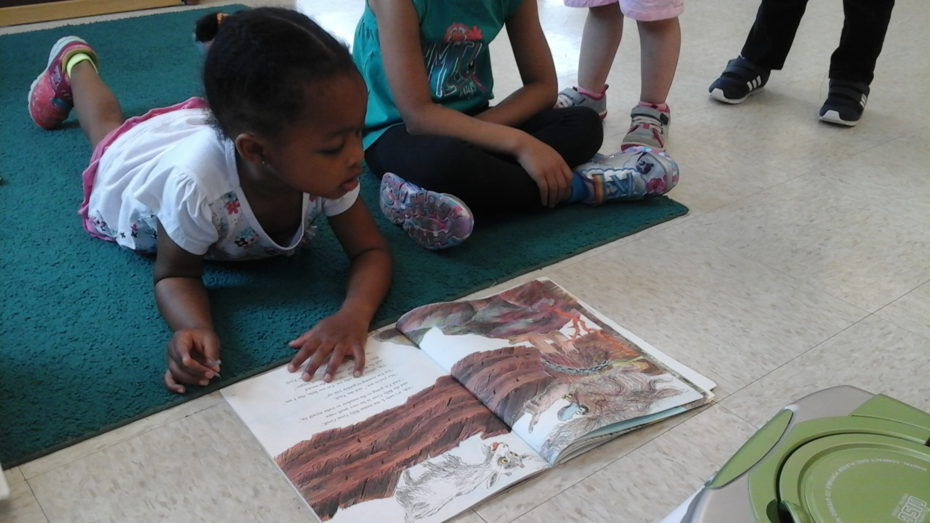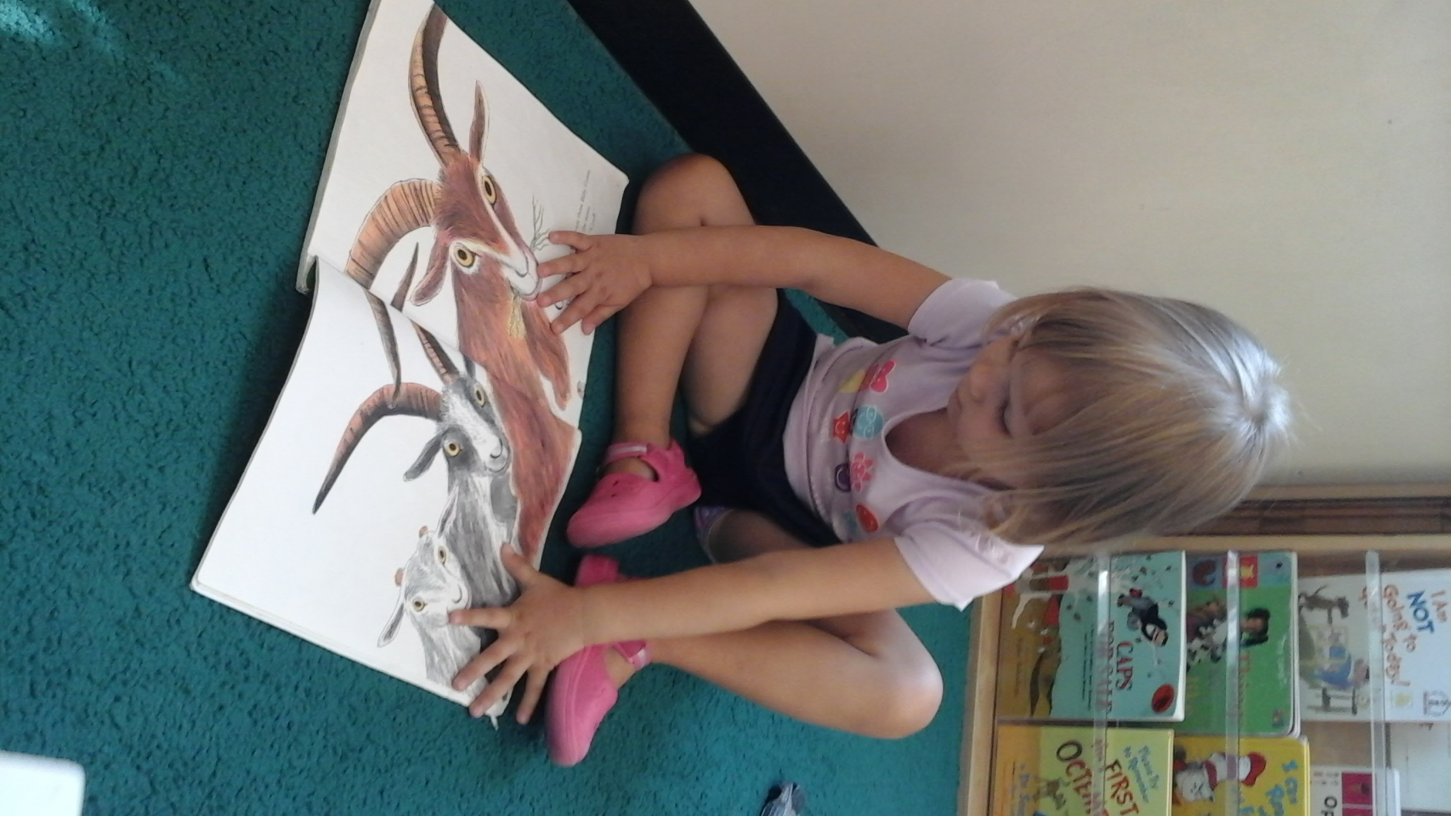

The WCCC provides “healthy” mid-morning and afternoon snacks with milk or water. Parents are expected to provide a well-balanced lunch and beverage. Soda is not a healthy option to send for a beverage. Please refrain from sending sweets (candy, cake or cookies) as part of your child’s lunch. Alternatives include: crackers with cheese, jam, bite-size pieces of fruit or raw vegetables, bagel and cream cheese, muffins or breads, yogurt, sandwiches, pizza slices, juice, and milk. We do understand healthy eating can be a chore to get your child to do. Here are five strategies that could help improve nutrition and encourage smart eating habits:
- Have regular family meals.
- Serve a variety of healthy foods and snacks.
- Be a role model by eating healthy yourself.
- Avoid battles over food.
- Involve kids in the process.
Sure, eating well can be hard — family schedules are hectic and grab-and-go convenience food is readily available. These tips can help make all five strategies part of your busy household.

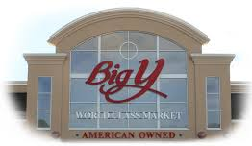
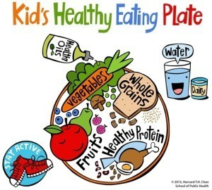
Big Y Supermarket
475 Hancock St., Quincy
Back to School Event
Saturday 09/09/2017
12:30pm to 2:30pm
Stop by the big Y and learn quick and easy healthy snack and meal ideas. There will be face painting, balloon animals, school supply drive and more! Sure to be a fun event for the family!

This month the classrooms will be learning about themselves; our feelings, our likes and dislikes, how are we different and the same? What color are your eyes? Classroom #4 will graph their eye color, how many are brown? The children of classroom #2 will look at themselves in mirrors and draw self-portraits. Get your body moving with room #6 to “Head, shoulders, knees, toes”, as they learn where that body part is and how it works. Explore and learn what are my senses and what do they help me do? Let’s learn and discover the world and people around us. How many people are in your family, what makes a family? Through books, discussions, songs, finger plays and hands-on activities children we learn about themselves and the people we share our world with! We will become aware of our bodies and what we are capable of doing. Strengthening our self-help skills as we become independent, confident learners.
